MARY- THE WONDER WOMAN

**Respected fathers & brothers,**

**Pope John Paul II says, “The church contemplates with wonder and celebrates with veneration the immense greatness conferred on Mary by the one who wanted to be her Son.” The church from the beginning till now looks at Mary with wonder. And I would like to call Mary as a Wonder woman, because she is the most famous and influential woman who ever live on earth. The church also is wondering at her greatness. I will tell you why I call her as wonder woman.**

**First of all she is THE MOTHER OF GOD. In 431 the council of Ephesus solemnly proclaimed that Blessed Virgin is not only the mother of Jesus but also the Mother of God. Although the early Christians used the title ‘*Theotokos*’- Mother of God, from here on this title became more prominent among the Christians. I think this is the greatness that a woman ever imagines to reach in her life on earth.**

**Secondly blessed virgin is THE MODEL OF PERFECT LOVE. We may think that, since Jesus is fully God, he had no need of a teacher. But the mystery of incarnation reveals that the Son of God came into the world in a human condition similar to us in all things except in sin (Heb.4:15). Just like any other human being, Jesus also needed the care of the parents as he grew up. Here the special gift of God showered on Mary and made her particularly suitable for the task as the mother and the teacher. In the concrete circumstances of everyday life, Jesus could find in her a model to follow and imitate an example of perfect love for God and for the brothers** and **sisters.**

**Again, Mary had a ROLE IN JESUS’ SAVING MISSION. Beginning with Simon’s prophecy, Mary intensely and mysteriously united her life with Christ’s sorrowful mission. She became her son’s faithful co-worker for the salvation of human race. And in fact the mental suffering that Mary underwent would reach its culmination in the passion of Christ.**

**Mary was co operating with the will of the Father by her personal obedience. Her obedience was not ended when she gave birth to Jesus. She is also THE PERFECT MODEL OF OBEDIENCE TO THE WILL OF GOD.**

**Jesus works MIRACLE AT THE REQUEST OF MARY. The best example that given in the gospel is the episode of the wedding feast at Cana. As a skilled housewife, Mary, came to know the sad situation of the family and approached immediately for aid. Here Mary became a cause for the strengthening of the faith of the disciple. After the miracle in Cana, St. John in his gospel says, “The disciples believed in Him.”**

**MARY IS THE MOTHER OF ALL. At the cross before his death, Jesus called John the beloved disciple and handed over his mother to him saying, “Behold your mother.” Then Jesus said to his mother, “Behold your son.” In fact it was the beginning of the new mission and motherhood of Mary to the entire people of the world. Here Mary took up her new task of spreading the new life in Christ among the people.**

**The church firmly believes in THE ASSUMPTION OF MARY. The dogma of Assumption affirms that Mary’s body was glorified after her death. In fact, while for other human beings, the resurrection of the body will take place at the end of the world, but for Mary the glorification of her body was anticipated by a special privilege. In the dogma of Assumption, Pope Pius XII avoided using the term ‘resurrection’ and did not take a position on the question of blessed Virgin’s death as a truth of faith.**

**MARY AS THE WITNESS TO WHOLE PASCHAL MYSTERY OF JESUS. Blessed Virgin may be the only human being who was present with Jesus from the birth to the Ascension. Although the evangelist did not report that Jesus appear to Mary after the resurrection, in most probability, it may be a ‘knowledgeable omission’. Because the aim of Jesus’ apparition was to strengthen the faith of the disciples. But for Blessed mother it was not needed. Because she is the ‘mother of faith’. However, Jesus would have been appeared to Mary several times although the evangelist avoided this record from their writings.**

**The Christians consider MARY AS THE QUEEN. Holy Father says, “Mary is the Queen not only because she is the mother of God, but also she is associated with the new Eve with the new Adam. She cooperates in the work of the redemption of human race. The dogma of Assumption explains that, ‘the Blessed Virgin in body and soul was taken into heavenly glory. And she was exalted by the Lord as Queen of all things.**

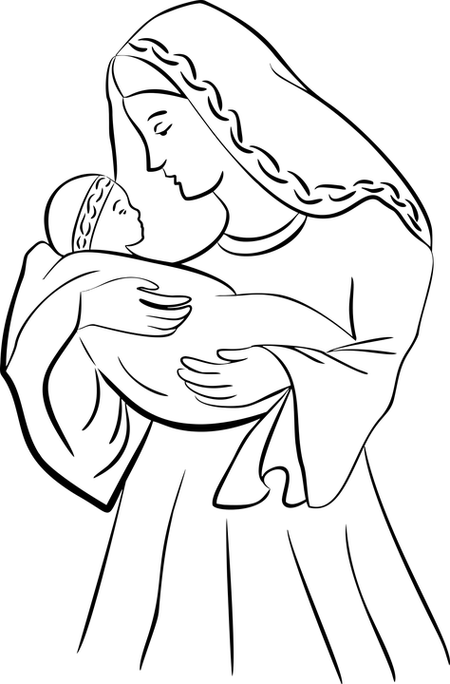**All these things show that Mary is not a normal woman but a woman with unique characteristics. And I would like to continue to call her as the ‘wonder-woman.’ One of the secrets of her power may be is that she is always close to Jesus. Thus the characteristics of Jesus became hers too. It is not at all possible for us to become a ‘wonder man’. For this the only thing that we need to do is to be close to Jesus. He will make us people with graceful character like the Blessed virgin.**

**Thank you**